APPENDIX A

Dear Cllr Malcolm and Jill,

Please see the below and I hope the photos will come through from our highways team.

See you at 1930 this evening in the village hall.

Regards

==================================================

Date: 8 July 2026
Subject: RE: Petition Submission – Road Safety Improvements, Tixall, Ingestre to Great Haywood

Good afternoon Cllr Mynors,

Further to Garry’s email below, we have previously raised the concerns regarding collisions on Great Haywood Road and Mill Lane with our Road Safety Team. I will check with the team to see if they have any further information regarding the incident yesterday, however in May, we were advised that there had been two reported injury collisions on Great Haywood Road during the last three full years of available data (January 2022 to December 2024). Of these, one resulted in serious injuries and one resulted in slight injuries. As Garry mentioned, these road traffic collisions are spaced out and there is no discernible pattern, however based on the collision information available, a common factor appears to be drivers travelling too fast for the road conditions or misjudging the narrow width of the carriageway.

I appreciate that the collision data does not always align with local perceptions, and residents often refer to damage-only collisions and near misses, but sadly we’re not in a position to take these into account.

In terms of the action taken so far, we have commissioned a speed and volume survey on Mill Lane, Great Haywood through your DHP. We have received the survey data back from our Traffic Data team and are currently reviewing this alongside data provided by our Development Control colleagues relating to Great Haywood Road and we will provide a further update regarding this as soon as we can.

In the meantime, I have checked our Speed Compliance Tool, which uses connected vehicle data from approx. 135,000 vehicles recorded between January 2024 and December 2024. The data indicates that the 85th percentile speed along the route (the speed at or below which 85% of vehicles travel) is 39mph. Furthermore, analysis of vehicle speeds at the bends along the route shows that speeds reduce further, with the 85th percentile speed falling to approximately 35mph, showing good compliance.

We have also carried out some improvements along this stretch, including the refreshing of three road markings on Great Haywood Road, completed on 18th June, as pictured below, including near to Bottle Lodge.

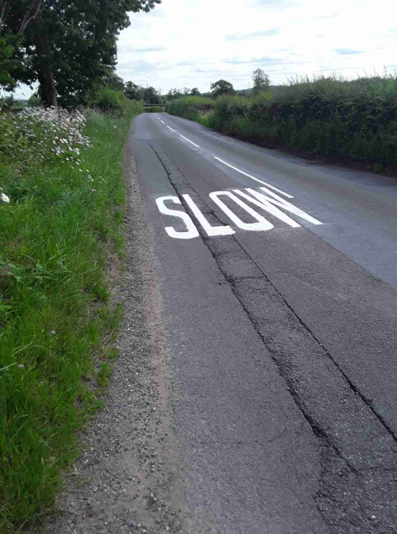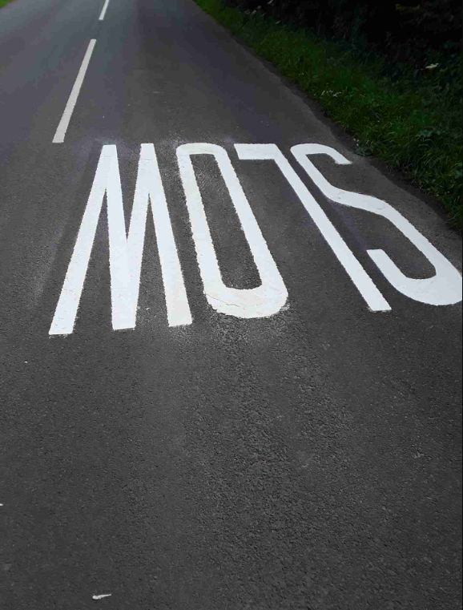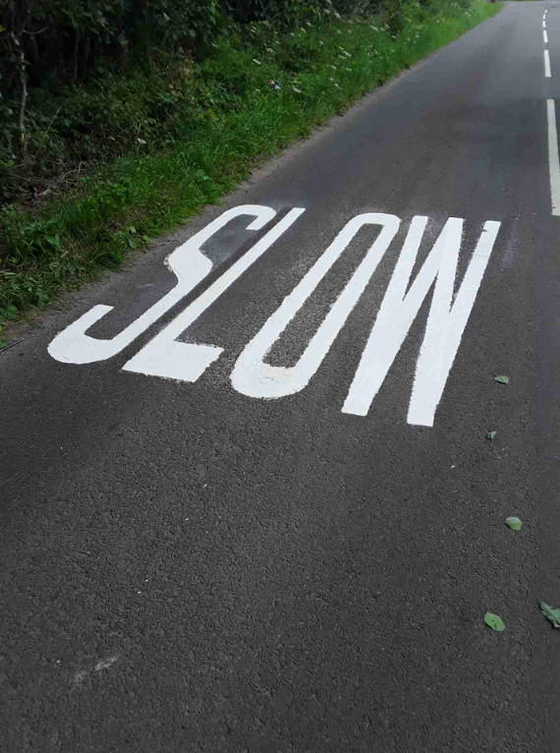

I will double check if any of the other SLOW markings would benefit from being refreshed, however a number of these were only refreshed in November last year.

In addition to the above, on 2nd July, four jobs were completed along this stretch to cut back self-setting trees which were obscuring road signs. I have included some of the before and after photos below.
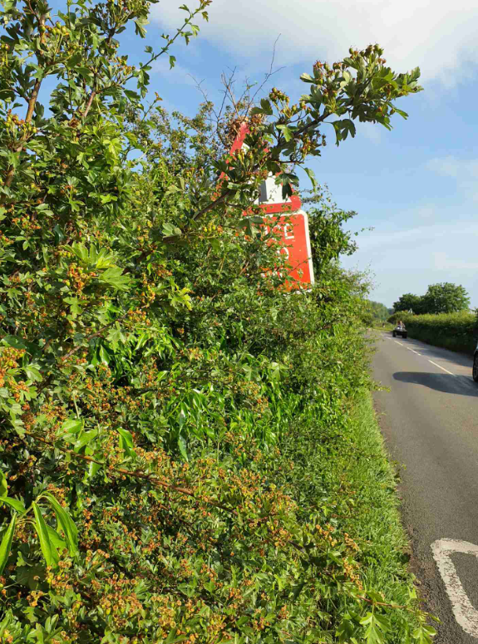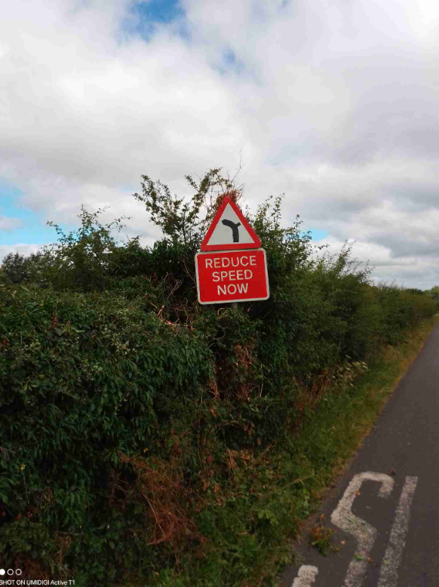

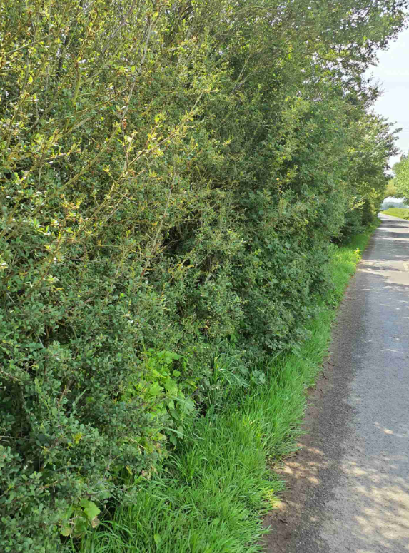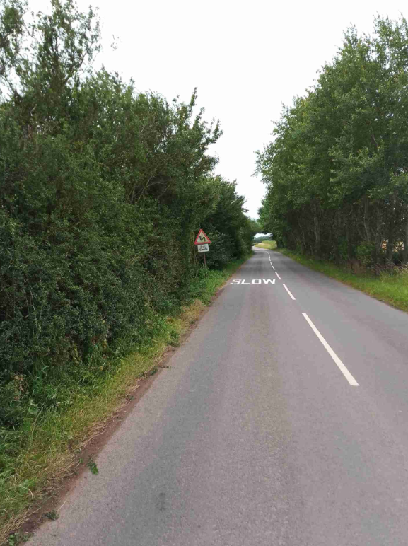

There are still some outstanding works required near Bottle Lodge to cut back and remove overgrown weeds, nettles and self-seeded vegetation that are obscuring road signs. This work is currently available for scheduling, and I will follow this up with operational colleagues and provide an update once scheduled.

In terms of any new signage and carriageway markings, there is already a significant amount of signing along this route, as illustrated on the annotated map below. However, as previously agreed, we will approach our Projects Team to explore whether the Bends Ahead warning sign closest to Great Haywood could be mounted on a yellow backing board to improve its conspicuity and match the existing sign near Bottle Lodge, as shown in the photograph below, and supplement with a “SLOW” marking.
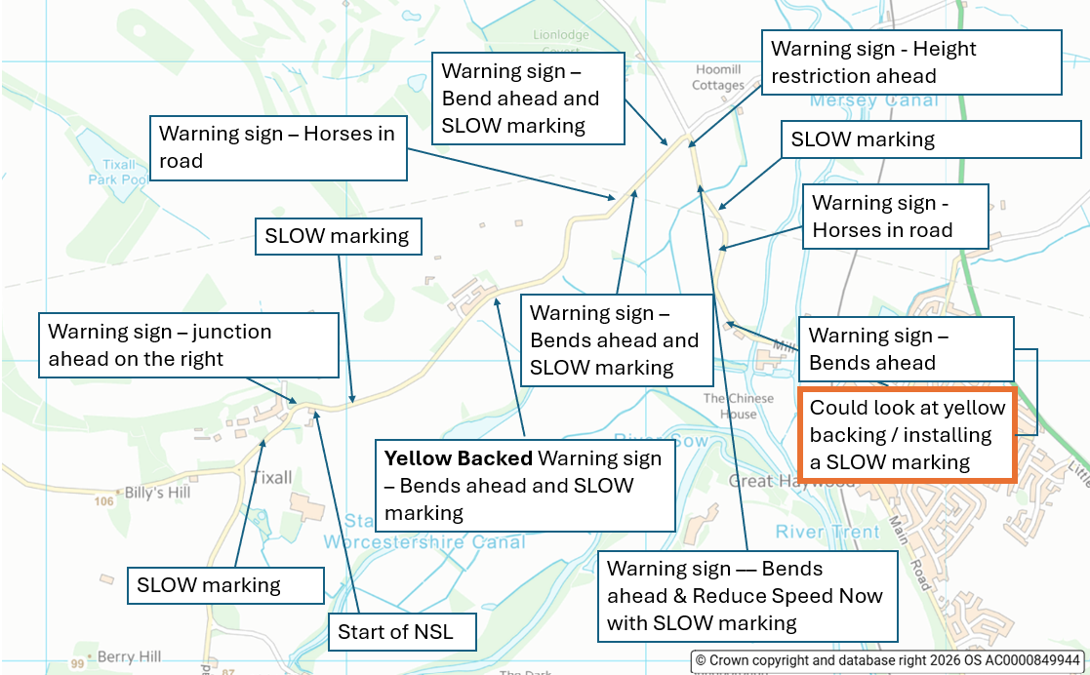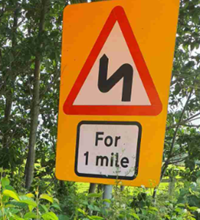

FYI - I will try and visit in person, with residents impacted by the speeding near bottle lodge and impact on their families and children.

======================================================================================

Firstly, I would like to assure you that Staffordshire County Council, as the Highway Authority, takes road safety extremely seriously and carefully considers reports of road safety concerns raised by local communities in accordance with its statutory duties and within its budgetary and resource constraints.

It may be helpful to explain how collision data is considered. Staffordshire County Council has a statutory duty to review road traffic collisions involving personal injury within its area and to take appropriate action to reduce their occurrence. As part of this, the Council maintains a database of police-recorded injury collisions, which enables it to identify locations where road safety funding and resources can be targeted most effectively to reduce casualties.

Whilst residents often raise concerns regarding near misses and damage-only collisions, the Council's assessment process is based on reported injury collision data from the Police. This is alignment with other local authorities and ensures that decisions are made using consistent, independently verified information and allows the Council to apply an evidence-led approach across more than 3,500 miles of highway network. In doing so, limited road safety funding can be prioritised towards locations where there is a demonstrated history of people being killed or seriously injured and where interventions are most likely to deliver measurable safety benefits.

I have worked closely with the local Community Highways Team, who have reviewed the available road traffic collision data for Great Haywood Road. For the most recent three full years of validated data (January 2022 to December 2024), there were two reported injury collisions recorded on the route, one resulting in a serious injury and one resulting in a slight injury. Whilst any collision is regrettable, the recorded injury collision history does not currently indicate a pattern that would warrant further highway engineering measures. It is also important to recognise that engineering interventions are not always capable of addressing the underlying causes of incidents.

Following receipt of the petition last year, I commissioned a speed and volume survey on Mill Lane through my Divisional Highway Programme. The survey data has now been received, and the Community Highways Team is currently analysing the results alongside other available data relating to Great Haywood Road.

In the meantime, I have been advised that existing anonymised connected vehicle data from approximately 135,000 vehicle movements recorded during 2024 indicates that the 85th percentile speed along the route is anticipated to be 40mph. The 85th percentile speed, which represents the speed at or below which 85% of vehicles are travelling, is a recognised measure used in highway engineering and enforcement assessments. The Community Highways Team will be able to provide further detail once its analysis of the survey data has been completed.

I have also prioritised improvements to existing signage and road markings along this route, with recent lining works completed on 18th June and vegetation clearance on 2nd July. In addition, the team are investigating whether the existing 'Bends Ahead' warning sign closest to Great Haywood could be enhanced with a yellow backing board to improve its visibility, in line with the similar sign located near Bottle Lodge.

I appreciate that this information may not fully align with the experiences of local residents. However, the Council must base its decisions on the evidence available and ensure that road safety funding is directed towards locations where it will have the greatest impact on reducing casualties.

The Community Highways team will continue to review the information obtained from the recent surveys and will provide a further update once that assessment has been completed.”

Regards Cllr Andrew Mynors

