INGESTRE & TIXALL NEWS
February 2025
INGESTRE WITH TIXALL PARISH COUNCIL

Contents

Pages 2/3 – Parish News, Parish Council meeting dates; details on latest Planning Application
Pages 3/4 – Community News: Tixall internet outage, Ingestre phone box and Community Garden
Pages 4/5 - Village Hall update, Church News
Pages 6/7 – Other News; update on Shugborough
Pages 7/8 – Update from SCC: new Highways reporting system
Pages 8/9 – Update from SBC: grants available

PARISH NEWS
Reminder: Parish Council Meetings: meeting dates for 2024/25 are shown below and are also shown on the Parish Council website, where the Meeting Agendas and Minutes can be accessed, www.ingestretixallparishcouncil.co.uk

All meetings will take place on a Wednesday evening, from 7.30pm in Tixall village hall (unless otherwise stated) and you are all welcome to attend. Meeting dates are as follows:

- 12 March 2025 – Parish Council Meeting.

The meeting dates for 2025/26 have been agreed and are as follows:

- 9 April 2025 – Annual Parish Meeting **
- 14 May 2025 – Annual Meeting of the Council, followed by the Parish Council Meeting
- 9 July 2025 – Parish Council Meeting
- 10 September 2025 – Parish Council Meeting
- 15 October 2025 – Parish Council Meeting - replaces November 2025 meeting.
- 7 January 2026 – Parish Council Meeting
- 11 March 2026 – Parish Council Meeting

** We hope to have attendees from SCC’s newly opened Heritage Centre, along with our PCSO and we have secured attendance from a member of SBC’s bee friendly team.

Parishioners are invited to attend; refreshments and cake will be provided. This is your opportunity to hear what our invited speakers have to say and raise any issues directly with your Parish Cllrs.

We hope you will be able to join us.

……..

Parish Council Precept update

Parish Precept 2025/26: the Parish Council met in November 2024 and January 2025 to consider and finalise its budget for 2025/26. At the January 2025 meeting the budget was approved and the Precept request for 2025/26 agreed.

The decision was taken to set the Parish Precept for both Parishes for 2025/26 at £3.500.00 each. This represents an increase of £300.00 on last year for each Parish, which equates to a rise of £4.13 per annum for Ingestre and a rise of £2.70 per annum for Tixall, based upon the rateable value of an average Band D property. The increase is necessary to ensure the Parish Council can continue to meet its budget responsibilities and the Cllrs are keen to progress the implementation of road safety measures within the Parish, where possible.

The Parish Council will always strive to keep a tight rein upon its finances to ensure it offers the best value possible to its residents.

Skip Lorry visits for 2025. The Parish Council has recently agreed the following dates for the skip lorry to visit the villages:

- 5 April 2025 – 9.00 – 10.00am at Ingestre, opposite Home Farm Court. 10.15 – 11.15am at Tixall Village Hall car park.
- 11 October 2025 – details as above.

Please be aware that, due to a change in legislation, sofas or armchairs will not be accepted at the Civic Amenity Visits. This is due to legislation around Persistent Organic Pollutants (POPs) which are found in soft furnishings, these items cannot be crushed (as they would be in the collection vehicle) and need to be collected separately either by arrangement with Stafford Borough Council or taken to designated containers at the Household Waste Recycling Centres in Stafford and Stone.

……

Parish Councillor contact details

Malcolm Sindrey – Chairman. cllr.sindrey@sindrey.myzen.co.uk
Sue Haenelt – Vice Chairman. cllr.suehaenelt@protonmail.com
David Lees – Councillor. cllr.lees51@gmail.com
Jane Tinniswood – Councillor. cllr.tinniswood@gmail.com
Tric Parrott – Councillor. cllr.parrott@gmail.com
Keith Palmer – Councillor. cllr.palmer@outlook.com
Judy Eccleshall – Councillor. cllr.eccleshall34@outlook.com

Please use the above email addresses if you wish to contact your Parish Cllrs for Parish Council matters.

……

Planning Information and Applications:

For your information, the Parish Council has been informed/consulted on the following Planning Application since December 2024:

- 24/40007/TCA – 1 Lion Lodge, Ingestre Park Rd, Ingestre

If parishioners wish to view/comment on any Planning Applications then you can visit the Public Planning access site at Stafford Borough Council, link below:

https://www.staffordbc.gov.uk/planning-public-access

…….

Community News
UPDATE: Internet outage within Tixall
As residents will be aware, from the December 2024 Newsheet, the Parish Cllrs were due to meet with Sir Gavin Williamson. This meeting took place on Friday, 3 January 2025. The meeting was very productive, with Sir Gavin agreeing that the approach to the internet outage from Openreach was less than satisfactory and he agreed to follow this matter up with Openreach directly, on our behalf. Sir Gavin was keen to progress a site visit with Openreach and this matter remains ongoing. In addition, Sir Gavin issued a Press Release in January, please use the link below to access the Press Release: https://www.gavinwilliamson.org/news/gavin-calls-full-fibre-access-tixall-staffordshire

The Cllrs were very grateful for the support that has been provided by Sir Gavin and we hope that a positive outcome will be achieved. It is important to note that, Openreach have advised that an earlier roll out of full fibre to the village is not achievable, which is disappointing, however, we hope that their agreement to the installation of some form of protection to the box can be secured, whilst the village waits for the full fibre installation. A copy of the email response communication received from Openreach, following Sir Gavin’s intervention, is attached to this Newsheet for information.

The Parish Council will continue to follow up on this matter and provide updates to residents as/when there is news to share.

…..

BT Phone Box in Ingestre

In December 2024, the Parish Council was approached by Stafford Borough Council, who informed us that BT had taken the decision to decommission the phone box in the village, due to lack of use. We were asked to comment on this decision and were offered the opportunity to purchase the phone box for use as a community asset.

At the Parish meeting, in January 2025, the Cllrs considered this matter and it was resolved to purchase the phone box from BT, at a cost of £1.00. it was agreed to use this for the benefit of the community and if you have any ideas for what you would like to see it used for, please let your Cllrs know or email the Clerk.

……

Ingestre Community Garden
You may recall, from the December 2024 Newsheet, that we advised a community meeting would be held in the Spring to discuss the future of the community garden. The details of this meeting have now been agreed and are as follows:
Thursday, 3 April 2025, at 7.30 pm at Ingestre Orangery, with refreshments available
The meeting is scheduled to last for approx. 90 minutes and will take the following format:
- Introduction
- Power point presentation
- Table top activities
- Discussion
- Conclusion
Residents from Ingestre will receive an invitation via the post, by Friday 21 March and Tixall residents will receive the invitation via WhatsApp by the same day.
If you have an interest in the future of the Community Garden, then please come along to the meeting. It will be an opportunity to share your thoughts, hear what others have to say and help the Parish Council determine the future of the garden, for the benefit of all.
……….
Village Hall Update
Tixall & Ingestre Village Hall 100-Club update
The 100-club has had the following draws:
Month | Prize winners
January | 1st prize of £25 was won Liam Kilgallen  2nd prize of £10 was won by Nicky Cook  3rd prize of £5 was won by Kate Greatholder

To join the 100 Club please contact Nicola Woodhouse, nicola.woodhouse@btinternet.com or 01785 663262.
Coffee Mornings & Craft Sales with soup lunch are continuing, held on each 2nd Saturday morning from 10.30am until 12.30pm. Why not take the opportunity to come along, catch up with and meet your neighbours, buy cakes, cushions, cards, jams you can also re-cycle books & jigsaws.
For general hall enquiries, email tixallingestrevillagehall@gmail.com
For bookings, please contact Sheila Sindrey if interested on 01785 663767. The Hall can be hired for £10.00 per hour.
Coffee Mornings & Craft Sales. Support for these events is falling from residents and if things do not improve, then these may have to be cancelled, as stallholders are reluctant to attend, if there are no/little customers. Please do what you can to spread the word about these events and encourage all to attend, as it would be such a shame if they did have to cease. Thank you, your support is needed and appreciated.
…..
Church News
Details of Church Services in Ingestre and Tixall from February 2025:
Services in Ingestre – St Mary the Virgin Services:
- 9 Feb at 11:15am Ingestre Morning prayer service
- 23 Feb at 11:15am Ingestre Holy communion service
- 9 March at 11:15am Ingestre Morning prayer service
Services in Tixall, as follows:
- 16 Feb at 11:15am Tixall Family service
- 2 March at 11:15am Tixall Holy communion service
Service at St John’s Church, Bedford Avenue, Stafford, as follows:
- 5 March at 7:30pm Stafford, St John’s Ash Wednesday service
For more information contact the Church office 01785 253493
Other News

Here at Shugborough, things are underway for our biggest project yet – Shaping Shugborough: Designing for a Sustainable Future.
In February 2024 we received planning approval from Stafford Borough Council and we spent the following months preparing our teams operationally and carrying out a series of enabling works. From the beginning of this year our contractors O’Brien, will be arriving on site to set up their site compound.
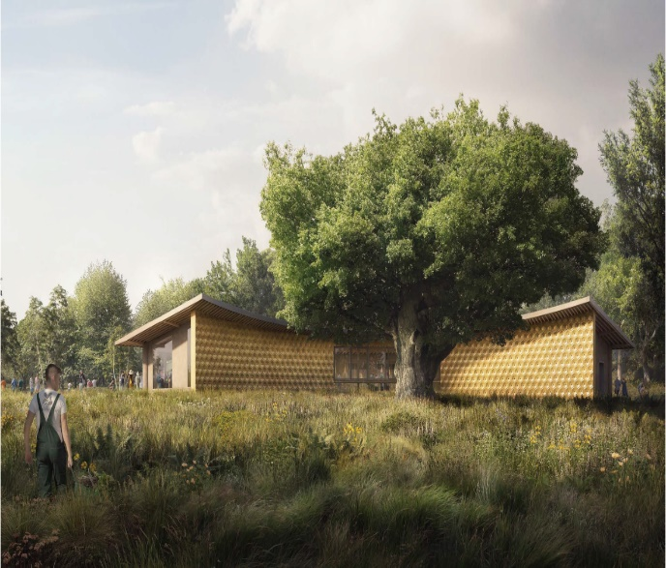
Soon official construction will begin and Shaping Shugborough will be underway. The building process will last 18 months, and we will be ready to open our new site in Spring 2026. Most of the building works will be taking place on the eastern part of the estate, which will limit the impact on visitors to the estate. From time to time, we may have to close paths, including those through the former sports pitches, Lichfield Drive and Bluebell Walk. Any emergency closures will be posted on our website and social media at the earliest opportunity.
The relocation of the vehicle entrance to the Lichfield Gates will improve safety and visibility for those arriving by car. The new car park's position will eliminate the need for cars to drive through the parkland, allowing us to reinstate historic paths, reopen the disused Lichfield Drive, and refresh the visitor experience.
The brand-new visitor reception will offer a range of facilities, including accessible and family-friendly toilets, a Changing Places toilet, a coffee shop, a dog wash, and a visitor shuttle drop-off area.
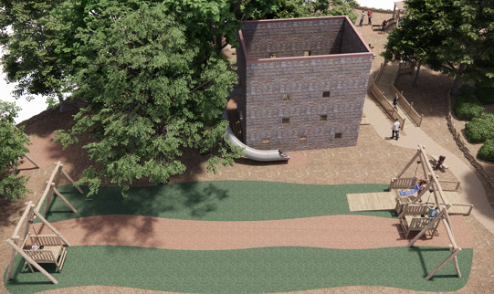
As part of our sustainable vision for Shugborough, the new visitor reception building will be constructed using renewable, locally sourced materials. A timber structure with straw bale infill will be used to minimise the carbon footprint during both construction and operation.
We are also excited to introduce a refreshed play experience at Shugborough, nestled in the woodland known as ‘Underlay Cop’. Designed to inspire the senses and spark the imagination, this new play area will be accessible to visitors of all ages and abilities, ensuring everyone can join in the fun.
Following consultation with local schools, we cannot wait to unveil a star attraction: a trio of zip wires running side by side, including one that is fully accessible. This feature promises an unforgettable adventure, where families and friends can enjoy the thrill of soaring through the trees together.
Getting to this stage has been a huge effort and we could not have got here without our dedicated staff, volunteers and partners, all working together to bring the vision for this project to life.
Stay connected with Shaping Shugborough!
Discover more about Shaping Shugborough: Designing for a Sustainable Future, through our onsite interpretation, where you can explore the vision behind the transformation. We will also be sharing stories, updates, and behind-the-scenes progress on our social media channels, so be sure to follow along!
For more information, scan the QR code below to visit our website and stay up to date with all the latest developments.
https://www.nationaltrust.org.uk/visit/shropshire-staffordshire/shugborough-estate


…….

Information from Staffs County Council



A new way to report highway issues
The way you can report potholes and other highways issues in Cannock Chase has been completely revamped.
The county council’s ReportIt system has undergone a transformation to make it easier for residents to report highways issues.
The new system is more user friendly, and gives people the option of having their own account where they can track the progress of their reported issue.
In response to customer feedback, people can also now report the condition of a whole road, and the language has been made much simpler.
The system has taken a year to develop, and although it has been tested extensively, the county council is inviting people to provide feedback that will further shape the system.
Reports made to the previous ReportIt system have been transferred over, so there is no need for people to make a new report.
Staffordshire County Council Cabinet Member for Strategic Highways Mark Deaville said: “This system has taken over a year to develop, and I hope it will make things easier for residents who want to report an issue on Staffordshire’s highways. This work is a really important part of our ongoing mission to fix more roads and improve customer satisfaction."
For more information about the new system, including some frequently asked questions, right click the link below and open the hyperlink.
Report It explained - Staffordshire County Council
Highways newsletters
Did you know that Staffordshire County Council issues eight highways’ newsletters per month, a newsletter for every district and borough? These newsletters highlight the latest highways stories across the county, and how the county council is fixing more roads, and emphasises local works that really make a difference to residents.
SCC are keen that as many residents sign up to them as possible, so why not sign up to receive these. Right click the link below and open the hyperlink to make sure you get the latest updates straight to your email inbox.
Staffordshire County Council

Information from Stafford Borough Council

A boost for Stafford Borough businesses in new year programme

Grants of up to £20,000 are now available for businesses based in town centres in Stafford Borough.
Stafford Borough Council has launched a new £125,000 funding which can help small and medium-sized businesses based in Stafford, Stone and Eccleshall in the latest addition to a popular scheme.
The High Street Boost programme has already supported many enterprises across the borough with financial support or expert advice as part of a range of initiatives - with the help being described as ‘invaluable.’
Now the council is encouraging others to apply for the latest round of grants of between £2,000 and £20,000 which can be used for website design, funding for training, specialist advice or office equipment.
Applications are open until the end of February and if people want to find out more, and apply, they can find all the details from High Street Boost Grant | Stafford Borough Council
And workshops are being rolled out in January and February following ‘popular’ demand with the chance for people to learn from business and retail experts with the chance of having further one-to-one support.
Funding for the initiatives has come from the UK Shared Prosperity Fund (UKSPF) with the borough council awarded one of the largest pots of money in the country. The local authority successfully put forward schemes to help the visitor economy, regeneration, climate change and culture.
Councillor Rob Kenney, Deputy Leader with responsibility for town centres, said the feedback they had received from business had been tremendous.
He said: “The High Street Boost programme has proved very popular so it is great to be able to offer even more support in the new year. It is often the high-profile projects that grab the headlines - but equally important is the need to grow our new and existing businesses and this initiative demonstrates the council’s ambition to do just that across the borough.
“I would urge those who have not taken advantage of this previously to get on board. It has been described as ‘invaluable’ and those businesses taking part are seeing the benefits - whether that be through new technology or expert advice.”
Janet Markwell, owner of The Corner Patch, a patchwork and quilting shop in Eccleshall, said: “I have found the support from my consultant helpful. As a result, I have made changes to the layout and displays in the shop, with lots of positive comments from customers following these changes.
“Having someone to give supportive criticism, look at what we do with fresh eyes, and share best practice is already having a significant effect. I am looking forward to the future sessions as I sure they will be equally beneficial.”
A workshop will be held on Wednesday, 19 February and small and medium businesses can see more of what they offer and how to sign up at www.staffordbc.gov.uk/high-street-boost
The ’High Street Boost’ scheme is run by experts ‘Good2Great’ who have helped businesses across the Midlands.
And for a complete list of the many initiatives to support local businesses go to Business Support | Stafford Borough Council

……

Parish Council website
Please visit the Parish Council website for information of meetings, etc
https://www.ingestrewithtixallparishcouncil.co.uk
If residents have suggestions or ideas for content that would be of interest and value to them, please email your suggestions to the Parish Clerk, clerk@ingestretixall.staffslc.gov.uk

Every endeavour has been made to ensure information contained in this Newsheet is correct at the time of production.

