Flu and COVID 2024 – Partnership Pack

To reduce the pressure on hospitals this winter, it’s important that people get their annual flu and COVID autumn booster vaccines.
Flu can be a serious or life-threatening illness, especially for those most at risk.
The COVID-19 and flu vaccine can:
- help reduce your risk of getting severe symptoms
- help you recover more quickly if you catch a respiratory infection such as COVID-19 or flu
- help reduce your risk of having to go to hospital or dying from COVID-19 or flu
- protect against different types of COVID and flu virus

Who is eligible for a flu vaccine?
You can get the free NHS flu vaccine if you:
- are aged 65 or over (including those who will be 65 by 31 March 2025)
- have certain long-term health conditions
- are pregnant
- school children aged from Reception to Year 11
- live in a care home
- are the main carer for an older or disabled person, or receive a carer's allowance
- live with someone who has a weakened immune system
- Social care staff without an employer-led occupational health scheme

Who is eligible for a COVID vaccine?
You may be offered a COVID-19 vaccine if you:
- are aged 65 or over
- are pregnant
- are aged 6 months to 64 years and have an increased risk of getting seriously ill from COVID-19 because of a health condition or treatment
- live in a care home for older adults
- frontline health and social care workers
- staff working in care homes for older adults

- More information about eligible health conditions can be found here: COVID-19 vaccine - NHS (www.nhs.uk)

TIMESCALES
- Delivery started in September for pregnant women and school children (flu vaccine)
- For other cohorts the main flu campaign started on 3rd October with main bulk of delivery to be completed before 31 December 2024
- School children completed by 13th December
- Care homes completed by 6th December
- COVID by 31st January 2025
- Both vaccinations can be given at the same time if people are eligible for both.

HOW CAN YOU SUPPORT THE CAMPAIGN?

Our aim is to increase the take-up from last year, especially in areas of lower vaccine coverage and amongst groups where we have previously seen lower vaccine uptake.

This includes the Pakistani community, White Any other including Eastern Europeans and in specific areas such as East Staffordshire, Cannock, Stafford and areas of Newcastle-under-Lyme.

In addition to the posts below, please schedule regular updates of local COVID walk-in clinics in your area:

https://staffsstokeics.org.uk/your-health-and-care/covid-19/walk-in-vaccination-clinics-in-staffordshire-and-stoke-on-trent/

We suggest using wording similar to our post which you can also share:

(9) Facebook | 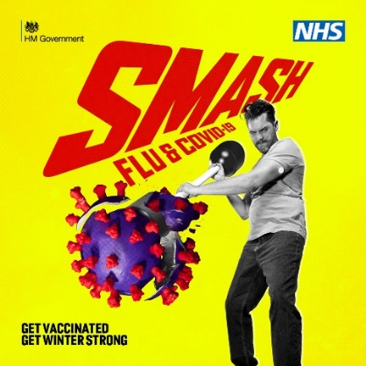

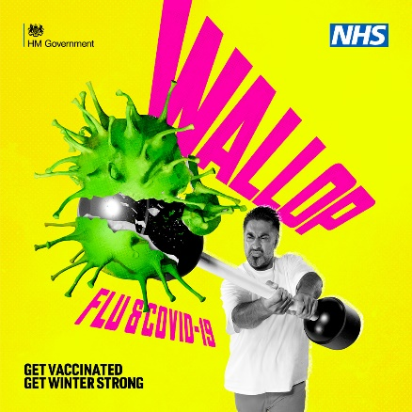
Please schedule each week with details of walk-in
COVID clinics in your area

Here is another image you can use for ethnic minority areas.

There is no pork derived or other animal derived products in the flu or COVID needle vaccine. However, the nasal spray used for children does contain a pork gelatine. An alternative needle vaccine can be taken instead.

FLU SOCIAL MEDIA
Adult Focus  Flu can affect adults in different ways. For some it’s a bad cold, but for others it can be life-threatening.  You can now get the free NHS flu vaccine if you:  - are aged 65 or over  - have certain long-term health conditions  - are pregnant  - live in a care home  - are the main carer for an older or disabled person, or receive a carer's allowance  - live with someone who has a weakened immune system.  Frontline health and social care workers can also get a flu vaccine through their employer.  Check your eligibility and book at ➡️ https://bit.ly/StaffsFluVaccine  You can also use apps to support your wellbeing and get winter strong. We have rated the best ones here. | 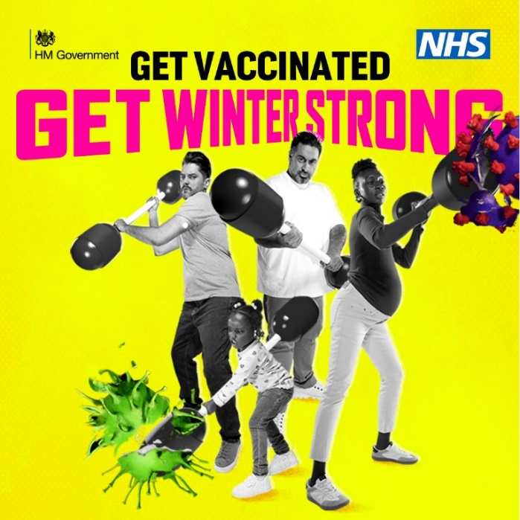
Adult focus pharmacy  Did you know that most local pharmacies now offer the flu vaccine?  Find out if you’re eligible for a free flu vaccination and if your local pharmacy is offering it here ➡️ https://bit.ly/StaffsFluVaccine  You can also pay to have the vaccine if you’re not eligible. | 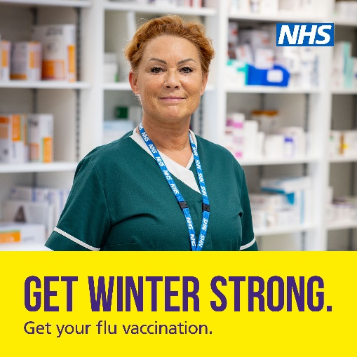
Pregnancy Focus  If you’re pregnant, having the #flu vaccine will protect you and your baby from flu complications this winter.  It’s especially important during pregnancy, as flu infections increase the risk of babies being premature or stillborn.  ➡️ Get the free NHS flu vaccine by booking with a pharmacy online or in the NHS App - https://bit.ly/StaffsFluVaccine  You can also use apps to support your wellbeing and get winter strong. We have rated the best ones here. | 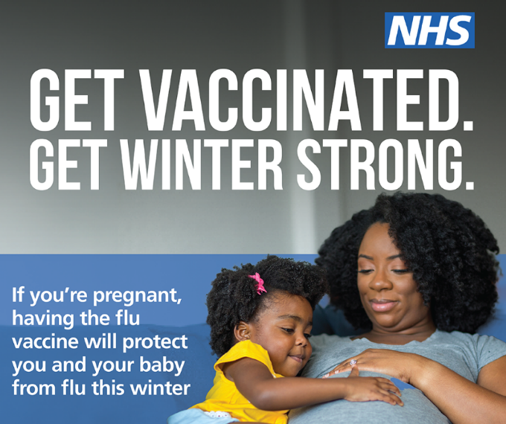
Child Focus  5 reasons to vaccinate your child with the free #flu vaccine this autumn:  - protects against more serious problems such as bronchitis and pneumonia  - it helps to protect you, and vulnerable friends and family  - no injections needed! For most children, it’s a quick nasal spray  - the vaccine has an excellent safety record  - you’re less likely to need to take time off work  The flu vaccine is free for children aged 2 to 16 and those with certain health conditions.  Check eligibility and find out more at ➡️ https://bit.ly/ChildFluVaccineNHS | 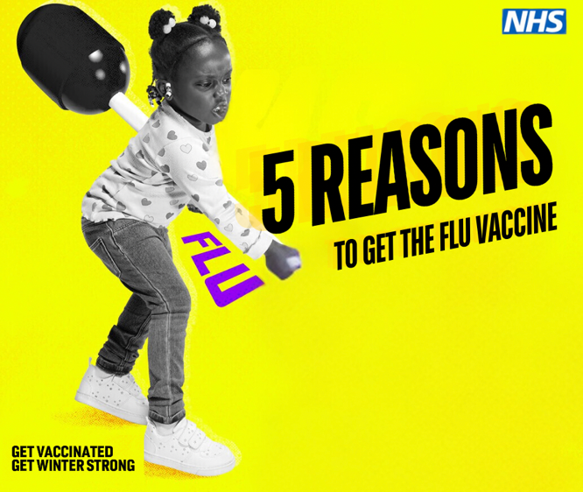
Flu can be more serious than you think, especially for children.  The flu vaccine is the best protection we have against flu, and for most school children, it’s needle-free!  Your child’s GP or school will contact you about getting your child vaccinated - it’s just a quick nasal spray.  Find out more at https://bit.ly/ProtectChildFromFlu | 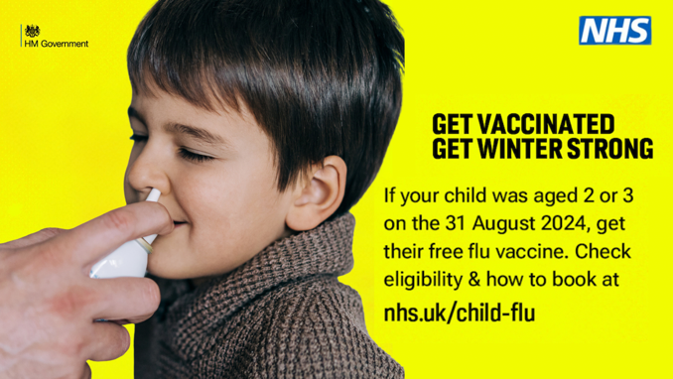

National Resources
There are more images and resources available on the Campaign Resource Centre (phe.gov.uk)

