INGESTRE & TIXALL NEWS
June 2023
INGESTRE WITH TIXALL PARISH COUNCIL

Contents

Page 2/3 – Parish News, Elections update, including Planning Applications recently consulted on, Latest updates from HS2
Pages 4/5 – Other Parish News, including canal tow path improvements Ingestre Community Garden, Lion Lodges update
Page 5/6 – Village Hall update
Page 6 – Church News
Pages 7/9 – Updates from Stafford Borough Council and Staffordshire County Council
Page 10/11 – Local information of interest: SCC employment opportunity, Cannock Chase AONB latest news
Page 11 – Parish Council website details

PARISH NEWS
Parish Council Meetings: meeting dates for 2023/24 have now been agreed and will be added to the Parish Council website, where the Meeting Agendas and Minutes can be accessed, www.ingestretixallparishcouncil.co.uk

All meetings will take place on a Wednesday evening (unless otherwise stated), from 7.30pm in Tixall village hall and you are all welcome to attend. Meeting dates for the rest of 2023/24 are as follows:

- 12 July 2023 – Parish Council Meeting. This will be held at Ingestre Orangery.
- 13 September 2023 – Parish Council Meeting.
- 8 November 2023 – Parish Council Meeting.
- 10 January 2024 – Parish Council Meeting.
- 13 March 2024 – Parish Council Meeting.

……..

Parish Council Elections – May 2023
The Borough and Parish Elections took place on 4 May 2023. The Election within the Parish of both Ingestre and Tixall was uncontested, however, there have been some changes to your Parish Councillors, as follows:

Ingestre Parish Cllrs: Sue Haenelt – voted as Vice Chairman for 2023/24 at the Annual Council meeting, held on 10 May 2023 and David Lees – Councillor. There is one vacant Councillor post at Ingestre, which we hope will be co-opted to in July.

Tixall Parish Cllrs: Malcolm Sindrey – voted as Chairman for 2023/24 at the Annual Council meeting, held on 10 May 2023, Tric Parrott – Councillor, Jane Tinniswood – Councillor and Keith Palmer – newly elected Councillor.

2 Councillors took the decision not to stand for re-election in the May elections: Nicola Woodhouse, who represented Ingestre and Nicholas Bostock, who represented Tixall. Both will be very much missed, in particular Nicholas, who had served on the Parish Council for 40 years+, however, we are very grateful that he has agreed to remain involved with the Canal Tow Path improvement project and be our ‘eyes on the ground’, whilst the works are completed.

We wish them both well and thank them for their support to the Parish Council.

Planning Applications.

For your information, the Parish Council has been consulted on the following Planning Applications since March 2023:

- 23/37151/HOU
- 23/37271/TCA
- 23/37526/S17 – HS2. Building works for the creation of a permanent water course crossing and associated reprofiling of earth required.
- 23/37431/LBC
- 23/37502/LBC

Tixall Solar Farm – residents may be aware of a Solar Energy Project that is being proposed for installation on land at Lower Hanyards. The Parish Council has been contacted by the agents working on this project to provide comments and make suggestions to help shape the design prior to submission of a full planning application.

If you wish to find out more about this project, visit www.tixallsolar.com
When the Parish Council is formally consulted on this proposal, residents are very welcome to attend our Parish Council meeting, to present any comments, concerns or to raise any questions. If you are unable to attend our meetings, then please submit any comments to our Parish Clerk at clerk@ingestretixall.staffslc.gov.uk

…….

Latest updates on HS2
In light of the recent Government decision to delay works to Phase 2a of HS2, much of the scheduled work has been put on hold, however, some of the environmental works will carry on and updates will continue to be added to the Parish Council website. Please do take the opportunity to view these as/when you can. There is a dedicated HS2 page, where all of the latest details, as received by the Parish Council, can be found.
https://ingestrewithtixallparishcouncil.co.uk/hs2/
In May 2023, the Parish Council received the updates below, from Balfour Beatty and Kier:
• The Government updated Parliament on their transport capital investment programme on 9 March 2023. The statement included an update on the HS2 project, recognising significant inflationary pressures facing all parts of the UK economy.
• The Government has reaffirmed its commitment to delivering HS2 from London Euston to Manchester, and this includes extending the railway between the West Midlands and Crewe (Phase 2a). However, in line with direction from the Government, HS2 Ltd are rephasing construction of Phase 2a as we develop the scheme further.
• The main civils works between the West Midlands and Crewe will be paused. During this time HS2 Ltd will be continuing with vital preparatory works already underway.
• Vital preparatory work that will continue includes completing live utilities works and habitat creation sites, in line with seasonal wildlife cycles.
• The land acquisition programme under the HS2 Phase 2a Act will also continue to ensure HS2 has the land needed to build the new railway.
•Continuing with the land acquisition programme and the utilities and environmental works already underway, will place the HS2 project in a strong position for when the programme of main civils works start.
• HS2 Ltd will also be continuing to progress with the development of the scheme design ahead of construction. HS2 Ltd are currently awaiting the award of the Design Delivery Partner (DDP) who will undertake this work on behalf of HS2 Ltd.
Early Civils Works 2 (ECW2) – Kier
• Most ECW2 work has paused with immediate effect. This includes detailed design development for the highway designs and any future construction work.
• Ecological surveys, given that they are time limited, will be paused. HS2 Ltd and Kier will undertake a review of our ground investigation and topographical works associated with highway design with some of these surveys being continued to completion. As such some traffic management to undertake these surveys will be taking place in upcoming months.
Utilities Diversions
• We will continue to deliver utility diversions at Chorlton, Tolldish Lane and Hanyards Lane. These are critical non-contestable diversions which will be delivered by National Grid Gas and Cadent.
• The remaining diversions are expected to be deferred and re-mobilised as part of the rephased works.

Other Parish News
Staffordshire and Worcestershire canal towpath improvements. The Parish Council is pleased to confirm that the work to the canal towpath commenced at the beginning of May. Below are some photos that show the early stages of the works that are happening:
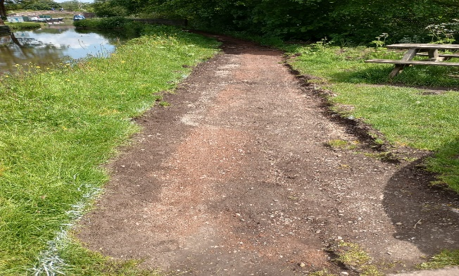
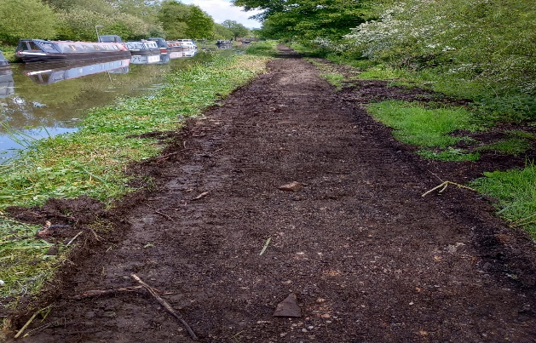

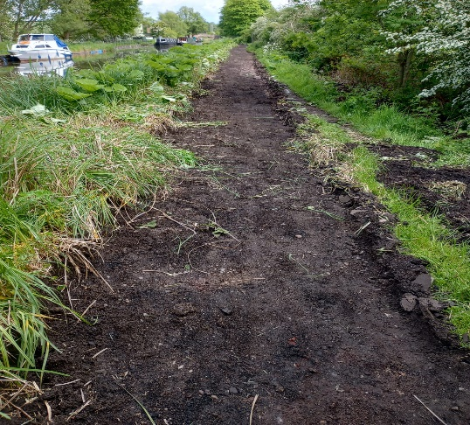
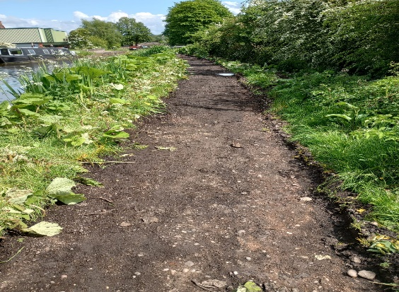




Nicholas Bostock (retired Parish Cllr) is taking a keen interest in the development of these improvements. He is working closely with the Canal and River Trust and is keeping the Parish Council updated as the project progresses.
Community Garden at Ingestre. The Parish Council has been assessing the condition of the Community Garden over the past few months, following an update by residents that the garden was looking a little unkempt, with the non-grassed areas being covered by weeds.
As part of this assessment, the Parish Cllrs decided to try to secure some grant funding to help with the purchase of tree plaques and holders for the numerous trees in the garden. Unfortunately, on this occasion, our application was not successful. However, we will not be deterred and Cllr David Lees and our Parish Clerk will continue to explore other possible funding streams. In the meantime, the garden does need to be maintained and we need the help of the local community to do this. Therefore, if you have a small amount of spare time (1-2 hrs twice a year) why not join a Working Group and support us with some general tidying up and weeding tasks. Cllr Lees is willing to be the lead person for the group. Therefore, if you have some time to spare and are interested in helping, please email the Parish Clerk to register your interest. Thank you.
Lion Lodges, Ingestre. Concern was raised in the Spring, by several residents, regarding the future of the properties at the Lion Lodge Estate. The Parish Council investigated this matter, as a priority and was able to resolve residents’ concerns quickly. HS2 issued the following statement to the Parish Council:
“These buildings are identified within our Environmental Statement as being of heritage value, and our impact assessment at the time of the ES set out that that we did not intend to impact the buildings.
Having checked with our property management and construction teams, this remains the case and we have no intention of demolishing these structures. Wherever it is financially viable, we will seek to bring properties up to required standards for us to be able to rent them out.
…..

Village Hall Update
Village Hall Report - 2022
A Trustee Report on the Village Hall for 2022 is attached for your information, as Appendix A.
Tixall & Ingestre Village Hall 100-Club update
The 100-club has had the following draws:
April:
- 1st prize of £25 was unsold
- 2nd prize of £10 was won by David Hyden
- 3rd prize of £5 was unsold

May :
- 1st prize of £25 was unsold
- 2nd prize of £10 was won by Sylvia Mould
- 3rd prize of £5 was won by Margaret Collier
To join the 100 Club please contact Nicola Woodhouse, nicola.woodhouse@btinternet.com or 01785 663262. Subscriptions, of £12.00 per year, are due to be paid in June, preferably by Standing Order.
Coffee Mornings & Craft Sales with soup lunch are continuing, held on each 2nd Saturday morning, from 10.30am until 12.30pm. Why not take the opportunity to come along, catch up with and meet your neighbours, buy cakes, cushions, cards, jams you can also re-cycle books & jigsaws.
For general hall enquiries, email tixallingestrevillagehall@gmail.com
For bookings, please contact Sheila Sindrey if interested on 01785 663767. The Hall can be hired for £10.00 per hour.
Church News
Please find details below of Church Services in Ingestre and Tixall from June until end of September 2023:
Sunday Services in Ingestre
Ingestre – St Mary the Virgin Services
11 June, 11:15am - Morning Prayer
25 June, 11:15am - Holy Communion
9 July, 11:15am - Morning Prayer
23 July, 11:15am - Holy Communion
13 August, 11:15am - Morning Prayer
27 August, 11:15am - Holy Communion
10 September, 11:15am - Morning Prayer
24 September. 11:15am - Harvest Holy Communion

Sunday Services in Tixall
Tixall – St John the Baptist Service
18 June, 11:15am - Morning Prayer
2 July, 11:15am - Holy Communion
16 July, 11:15am - Morning Prayer
6 August, 11:15am - Holy Communion
20 August, 11:15am - Morning Prayer
3 September, 11:15am - Holy Communion
17 September, 11:15am - Morning Prayer
For more information contact the Church office 01785 253493

……

Update from Stafford Borough Council
Asylum Centre Appeal: location of site is the former University Halls of Residence, Stafford Education and Enterprise Park, Weston Road, Stafford.
Appeal Inquiry: Planning Inspectorate Reference: APP/Y3425/W/23/3315258
A public inquiry took place in May in relation to an appeal by Serco against the decision of Stafford Borough Council to refuse planning permission for the ‘change of use’ of former student halls of residence to asylum seeker accommodation.
The inquiry was heard by Planning Inspector, Gareth Jones, who was appointed by the Secretary of State.
The decision of the Planning Inspector is expected in June 2023.
If you wish to find out more details about this matter please click here: Appeal Site: Former University Halls of Residence, Stafford Education and Enterprise Park, Weston Road, Stafford | Stafford Borough Council (staffordbc.gov.uk)

Who is taking your rubbish?? A senior councillor is calling on residents and businesses to support efforts to help tackle rubbish being dumped illegally in Stafford Borough.
Recently more than £1000 in fines have been handed out to people for various fly tipping offences. The environmental crimes included a discarded fridge in Stafford and household waste on the A51 near the village of Hixon.
And the borough council is also warning householders to make sure their waste is disposed of properly as they can face being fined or prosecuted under fly tipping legislation.
A series of fixed penalty notices have been issued over recent months with:
- A £400 penalty for a Wolverhampton man who dumped a fridge on a grass verge in the Holmcroft area of Stafford
- A woman from the village of Weston who was given a £200 fixed penalty after her waste ended up on the A51
- A man from Lightwood in Stoke on Trent whose old carpet (pictured) was found in Dog Lane, Hanchurch. He was ordered to pay £200.
- A woman from Newcastle under Lyme was fined £200 after waste from her home was found in Chase Lane in the village of Tittensor
- And finally, a local man was given a £100 fixed penalty notice after bags of household waste were dumped in Marston Road, Stafford

Many offenders claim to have paid a ‘white van man’ to get rid of their rubbish. But the borough council say residents should only use registered waste carriers or could find themselves facing punishment if rubbish is discarded illegally.

Councillor Ian Fordham, Cabinet Member for Environment, said: “Fly tipping, littering and other environmental crimes are a blight on our communities. They can cause environmental damage, they attract anti-social behaviour, make areas look untidy, have an adverse impact on the quality of life for our residents, and can ultimately be detrimental to attracting investment to our area.
“I would ask people to report any such incidents, in confidence, to us. It is with the public’s help that we are able to trace those responsible - and I hope that the fines received will discourage others from breaking the law.”
He added: “Thank you to all those in the community who continually support our efforts to keep our wonderful borough tidy. We all have a duty to make sure we look after our area - so let’s not allow a small minority spoil it for the vast law-abiding majority.”
Some tips to avoid breaking the law:
- Always check credentials of people offering to take rubbish https://environment.data.gov.uk/public-register/view/search-waste-carriers-brokers
- Ask where they are going to dispose of the waste
- Always get a receipt

For more information www.staffordbc.gov.uk/alternative-waste-collectors
You can contact the council in confidence to report environmental crimes at grimewatch@staffordbc.gov.uk or 01785 619402.

Residents to have say on sex shop policy in Stafford Borough

Residents and businesses will be asked to have a say on proposals to improve regulation of potential lap dancing clubs and sex shops in Stafford Borough.
Senior councillors will be discussing a report on a draft ‘Sex Establishment Policy’ for the area and will be asked to give the go ahead for the public to be consulted on the new policy.
The proposals aim to give councillors greater control over potential sex establishments, such as how they operate and where they can be located. And the policy would help thwart legal challenges and appeals if the council opposed applications for premises - for example lap dancing clubs, sex shops, and strip shows.
It would also mean applications for new venues must be heard by the borough council’s Licensing Sub-committee.
A report to the council’s cabinet on Thursday (8 June) states that the policy ‘gives the council and local people a greater say’ if applications were submitted to operate such establishments in their neighbourhood.
It adds that the policy would make sure venues could not open in unsuitable locations - and lists schools, places of worship, and children’s play facilities as places to be taken into consideration if an application was made.
If given the green light a six-week consultation would get underway from next week (14 June) with a final decision on the new policy expected to be made at a meeting of the council later this year.
Councillor Ian Fordham, Cabinet Member for Environment, said the policy would give more transparency in decision making to applications for sex establishments in the borough.
He said: “This policy would give the council and community more control if applicants want to open these types of premises - or vary an existing licence - and it provides us with a stronger position to resist any legal challenges to our decisions.
“If the report recommendation is agreed on Thursday, then I hope local people and businesses will take the opportunity of giving us their feedback on the new policy as part of the consultation.”
You can see the full report by visiting the SBC website:
https://www.staffordbc.gov.uk/cabinet

The meeting will take place on 8 June 2023.

Updates from Staffordshire County Council
Latest update from Staffordshire County Council, keeping residents up to date and informed about activity being carried out by their Highways teams.

Pothole priority fund
Our highways crews will be carrying out additional pothole repairs, as part of the recently announced £2 million investment into local priority defects. The money is coming from the £4 million that the county council has received from the Department for Transport’s national pothole fund.
We know from feedback from you as residents, that potholes can often frustrate our communities, and whilst this additional funding won't solve the pothole problem completely, it will allow us to address those defects around the county that are a priority within our neighbourhoods.
County councillors have been working closely with their local Highways team to agree what repairs will be delivered through the additional funding this year.
In addition to the above works, Staffordshire County Council are investing an extra £30m in highways over the next two years, which will see us deliver a number of major reconstruction schemes, junction improvements and the comprehensive repair and surface dressing of hundreds of other roads.

Surface dressing hits the half a million mark
Our programme of surface dressing has been in full swing over the past few weeks. So much so, that we have now resurfaced more than half a million square metres of highways in Staffordshire.
Preventative maintenance is the most cost effective and environmentally responsible method to maintain our roads and helps prevent the development of potholes and other damage.
Preventative surface treatments--such as surface dressing--is fast, efficient, and causes minimal disruption to road users.

Following preventative maintenance works, inspections are carried out to assess the quality of the treatment and identify any issues. This includes checking for loose chippings, stone loss, rutting, and signs of premature deterioration.
Although it's rare that anything goes wrong, we can encounter certain issues; such as unfavourable weather conditions contributing to early deterioration of surface treatments, or heavy traffic loads causing some stone loss (particularly around junctions). We will always try to resolve any issues quickly, and where necessary arrange for remedial works to take place as soon as possible.

LOCAL INFORMATION OF INTEREST

New job opportunity

Farming in Protected Landscapes Officer
Staffordshire County Council is looking for an enthusiastic and committed individual to join the Cannock Chase Area of Outstanding Natural Beauty (AONB) Team to help deliver the Farming in Protected Landscapes (FiPL) programme.
Created by Defra and managed by AONBs and National Park teams across England, the programme helps farmers, land managers and others to deliver work on the farmed landscape under the themes of climate, nature, people and place.
This is an opportunity to make a real difference to farming and land management in the AONB and to help conserve and enhance the natural beauty of this nationally important landscape.
For further details on this part time role and information on how to apply please see here .
For any further information, please contact Ian Marshall (AONB Development Officer) at: ian.marshall@staffordshire.gov.uk
For more information on the Farming in Protected Landscapes Programme please see our website for details
……
Cannock Chase AONB Latest News

Waymarking Improvements

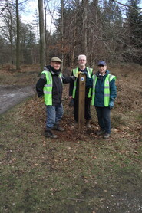
Cannock Chase AONB in partnership with The Ramblers are producing an updated series of self-led walks to assist with visitor management at some of the busiest sites on the Chase.
The walks predominantly follow Public Rights of Way (PROWS), and in preparation for the launch of the new walks, volunteers are replacing/upgrading waymarkers and posts to help navigation along the routes. The PROWs are marked with blue arrows to identify bridle paths and yellow arrows indicating footpaths – both of which are open to walkers. The new leaflets will contain a map of each route, together with a route description and features of interest to see along the way.

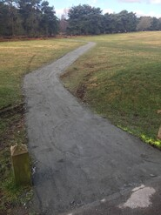
Toc-H Trail Improvements
We are excited that the first section of the Toc-H Trail improvement is now on the ground. An access path has been put in to connect the Marquis Drive Visitor Centre area to the Toc-H Car Park. Inspiring Healthy Lifestyles are working with a range of local community groups and schools from Hednesford to help make improvements to the trail and viewing platform to ensure it is more accessible for people. Partners involved in this project include AONB, Staffordshire County Council, Cannock Chase District Council, Hednesford Town Council, Inspiring Healthy Lifestyles and Together Active

Parish Council website
Please visit the Parish Council website for information of meetings, etc
https://www.ingestrewithtixallparishcouncil.co.uk
If residents have suggestions or ideas for content that would be of interest and value to them, please email your suggestions to the Parish Clerk, clerk@ingestretixall.staffslc.gov.uk

Every endeavour has been made to ensure information contained in this Newsheet is correct at the time of production.

