INGESTRE & TIXALL NEWS
November/December 2022
INGESTRE WITH TIXALL PARISH COUNCIL

Contents

Page 2/3 – Parish News - Latest updates from HS2
Pages 3/4 – Other Parish News, including canal tow path improvements, Holdiford Road and Ingestre Community Garden
Page 4/5 – Village Hall update/Church News
Page 5/7 – Updates from Stafford Borough Council and Staffordshire County Council
Pages 7 – Local information of interest: County Lines update
Page 8 – Parish Council website details and Christmas wishes from your Parish Council

PARISH NEWS
Parish Council Meetings: the next Parish Council meeting will take place on Wednesday, 9 November at 7.30pm in Tixall village hall and you are all welcome to attend.

Meetings for the early part of 2023 will take place on Wednesday evenings, as follows: 11 January and
8 March, both starting at 7.30pm. Further meeting dates for 2023/24 to be arranged.

Latest updates on HS2
The HS2 Phase 2a Engagement team are continuing to hold monthly virtual one-to-one meetings with local residents and stakeholders. Further dates have now been confirmed for July to December 2022.
Local residents, businesses, representative and community organisations can join to ask any questions they may have about the HS2 programme and works in their area. This can be anything from questions around where the Phase 2a route is going, how we will be building the railway and what works are happening in their local area, to the community funding available and the job and business opportunities.
Appointments are available to book on the following dates:
Wednesday 23 November, 10am – 7pm – Register Here
Wednesday 14 December, 10am - 7pm – Register Here
Registration links for all dates can also be found via the HS2 Events listing page at www.hs2.org.uk/events
HS2 Phase 2a – Community Newsletter and upcoming engagements events
The latest Phase 2a update newsletter is now available on the HS2 website. This provides an update on activity in your local area, including road modifications and utility diversion works. We have also shared an update on upcoming events, the community funds available and information on the creation of our ‘Green Corridor’.
To access the newsletter please click here
Information on our upcoming in-person and online engagement events are outlined below.
Information webinar:
Our progress in designing and building HS2 Phase 2a - Wednesday 9 November
- In this session attendees will hear from HS2 early works contractors on the work they have been undertaking during 2022 and what will be taking place in 2023.
You can find out more and register for the webinar by clicking here

In-person one-to-one appointments and drop-ins
Throughout November, our engagement and engineering teams will be available from 12pm to 7pm at a number of venues across the Phase 2a route to speak to residents on a one-to-one basis about HS2 and what it means for the local area.
- Between 12pm and 6pm appointments will be available for you to book. Alternatively, you can drop-in between 615 pm and 7pm without the need to book an appointment.
For details on locations and dates and to register for an appointment please click here
……
Balfour Beatty, on behalf of HS2 will be commencing environmental works to land south of Ingestre Park Road from the end of October to late November 2022. More details about the works can be seen on the attached works notice.
Kier, working on behalf of HS2 will be commencing survey works to allow for the construction of a roundabout at the junction of Hoo Mill Lane and Ingestre Park Road, as well as passing bays through Tixall along the Great Haywood Road. These surveys and works will commence in November 2022 and will continue until the Spring 2023. More details about all of this can be seen on the attached works notices.
……

Other Parish News
Staffordshire and Worcestershire canal towpath improvements. To the best of our knowledge this project remains on track for work to commence on the towpath improvements in early 2023.
The Parish Council hopes to see the improvements completed well in advance of the 2023 summer period.
Community Garden at Ingestre. The Parish Council wishes to invite residents of the Parish to take advantage of the fruit that is maturing in the Community Garden. Much of the fruit is being left unpicked and is therefore rotting in the garden, which is such a shame, when residents can use it to make jams, chutneys, etc
It has also been brought to the attention of the Parish Council that the garden is beginning to look a little unkempt, in particular the non-grassed areas, which are becoming somewhat covered by weeds. The Parish Cllrs are looking into this and we hope that we can secure the help of Ingestre residents to help with routine maintenance from time to time. If you have some time to spare and are interested in helping out, please email the Parish Clerk to register your interest. Thank you.
Traffic proposals at Holdiford Road bridges. The Parish Council has been informed by Staffordshire County Council (SCC) that there is a current proposal to install traffic lights and a speed reduction from the current National Speed Limit to 40mph along Holdiford Road, from Tixall to Milford. This proposal is in direct response to ongoing investigations by SCC to improve road safety along Holdiford Road following a review of the accident history on the road over the River Sow bridge and the Staffordshire and Worcestershire Canal bridge. SCC have advised that due to the potential for head on collisions and reports of confrontation between opposing drivers, signalisation of both bridges was identified as the preferred option. Following detailed investigation, the signalisation option was confirmed as being feasible.
Due to the distance between the two bridges, it is proposed to signalise each bridge individually, but to run a co-ordinated system between the two sets of lights. This will help to control agricultural accesses in between the two bridges and allow for greater flexibility with respect to signal timings.
The Parish Council, understands from SCC, that formal consultation is anticipated to commence with residents and businesses this calendar year.

Village Hall Update
Tixall & Ingestre Village Hall 100-Club update
The 100-club has had the following draws:
July:
- 1st prize of £25 was won by Eric Enocson
- 2nd prize of £10 was unsold
- 3rd prize of £5 was unsold
August:
- 1st prize of £25 was won by Pat Deakin
- 2nd prize of £10 was won by Liam Kilgallen
- 3rd prize of £5 was won by Kate Greatholder
September:
- 1st prize of £25 was unsold
- 2nd prize of £10 was won by Clare Brant
- 3rd prize of £5 was won by Kathy Poole
October:
- 1st prize of £25 was unsold
- 2nd prize of £10 was won by Nicholas Bostock
- 3rd prize of £5 was unsold

100 Club vacant numbers available to purchase at £1.00 each per month. Contact Nicola Woodhouse if interested, nicola.woodhouse@btinternet.com or 01785 663262.

Coffee Mornings & Craft Sales with soup lunch are continuing, held on each 2nd Saturday morning, from 10.00am until 12.30pm. Why not take the opportunity to come along and get warm whilst catching up with and meeting your neighbours, buying cakes, cushions, cards, jams you can also re-cycle books & jigsaws.
The Village Hall is available for hire – please contact Sheila Sindrey if interested on 01785 663767.

Church News
Please find details below of Church Services in Ingestre and Tixall during November and December:
Sunday Services in Ingestre
Ingestre – St Mary the Virgin Services
13 November, 10.45am – Remembrance Day service
27 November, 11.15am – Holy Communion
11 December, 11.15am – Morning Prayer
Wednesday, 21 December, 7.30pm – Carol service
Saturday, 24 December, 11.30pm – Christmas Holy Communion

Sunday Services in Tixall
Tixall – St John the Baptist Service
6 November, 11.15am – Holy Communion
20 November, 11.15am – Morning Prayer
4 December, 11.15am – Holy Communion
18 December, 6.00pm – Walking Nativity and Carol service
25 December, 9.00am – Christmas Holy Communion
1 January 2023, 11.15am – Holy Communion

For more information contact the Church office 01785 253493

……

Updates from Stafford Borough Council
Time to give views on plans for the future of Stafford Borough
Residents, businesses and organisations across Stafford Borough are being urged to give feedback on future plans for the area.
A seven-week consultation on the new ‘Local Plan’ is now underway.
The ‘Local Plan’ sets out a proposed planning strategy for Stafford Borough until 2040. People can give their views on the ‘Local Plan - Preferred Options Report’ until 12 noon on Monday 12 December.
The plans will be available in libraries, public exhibitions and drop-in sessions, with people also able to view proposals and take part in the consultation through the council’s website.
Since the current local plan was adopted in 2014 significant changes in national planning guidelines have been introduced, which have had an impact on the council’s local policies.
It is important to make progress on the new ‘Local Plan’ so that policies are in place, and potential land for building is allocated to meet future development needs across the borough.
Councillor Frances Beatty, Cabinet Member for Economic Development and Planning, said: “This will be a widespread consultation and we are very keen that as many people as possible are aware of what will be the blueprint for the whole of the borough for the next 20 years.
“It is very important we have an up to date, adopted plan so that everybody will know where building can take place, how much development will be allowed, and when this will happen.”
Highlighted in the plan are proposals for new schools, a GP surgery, indoor leisure, and a railway station as part of a garden village in the north of the borough - with a network of cycling and walking routes, around 6,000 homes as well as employment land.
The ‘Local Plan,’ along with all the comments, is due to go before the Secretary of State in late 2023 who will then appoint an Independent Planning Inspector to set up a public examination to decide whether the plan is acceptable.
You can find out more on the local plan, and how to give your feedback, from the council’s website
https://www.staffordbc.gov.uk/news/time-give-views-plans-future-stafford-borough

……

Updates from Staffordshire County Council

Pensioner household giftcards

Staffordshire County Council has provided a gift card to all pensioner households who were in receipt of Council Tax Support on 1 August.
This payment has been made from the Household Support Fund, which is a grant from the government.
Eligible households will receive a letter that details how to claim the gift card.
….

Staffordshire County Council are now emailing monthly Highways Bulletins, which are designed to keep residents up to date and informed about activity being carried out by their Highways teams.
For more details, see attached emails – Highways Bulletin June, July, September and October 2022 (no bulletin produced in August).
Below is information about some of the thing’s SCC are responsible for:

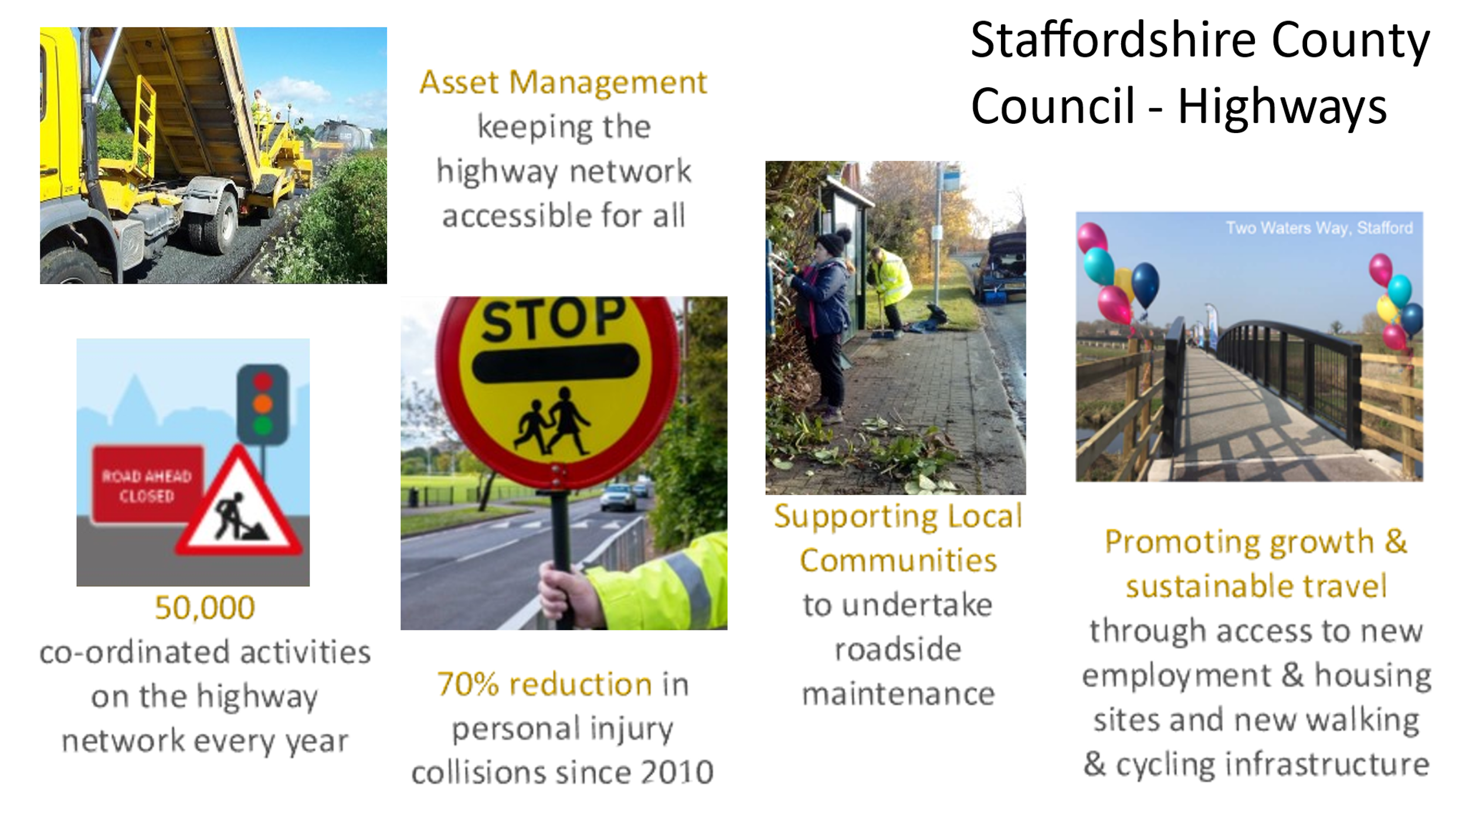
……

LOCAL INFORMATION OF INTEREST

County Lines
Would you know if someone was involved in County Lines?
Has a young person you know started to act differently?
If so it may just be those tough teenage years, but in some cases, it can mean that they’ve become involved in County Lines. That is the term used to describe gangs or organised criminal networks (also known as OCGs) who exploit young and vulnerable people into distributing and selling illegal drugs.
Young people can be groomed online or face-to-face, by a stranger or someone they know.
They often receive money, phones, expensive clothing, or jewellery in exchange for their work
Learn more about the signs here: https://www.staffordshire.police.uk/countylines

Parish Council website
Please visit the Parish Council website for information of meetings, etc
https://www.ingestrewithtixallparishcouncil.co.uk
If residents have suggestions or ideas for content that would be of interest and value to them, please email your suggestions to the Parish Clerk, clerk@ingestretixall.staffslc.gov.uk

The Parish Council would like to take this opportunity to wish all the residents of Ingestre and Tixall a very happy and peaceful Christmas and New Year.



Every endeavour has been made to ensure information contained in this Newsheet is correct at the time of production.

